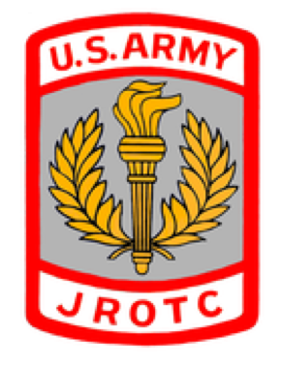Letters from Santa Fundraiser

Children just love receiving their own mail... especially from someone as magical as Santa Claus! Santa Claus emailed the Bozeman Army JROTC and wants to do something special for our community.

If you’d like Santa Claus to write your child a letter, he asks that you donate $3.00 to the Bozeman Army JROTC. He knows all about the great work the AJROTC does in our area and since he can’t be at the Fall Festival on Friday, November, 13, 2015, he wants to let the children know that he’s making his list, checking it twice and wants to do something for all those who are nice.

This could also make a great gift for a niece, nephew, cousin or any other child in your life. Best of all, the proceeds from these letters will help provide supplies and uniforms for the Bozeman Army JROTC.

Imagine your child's excitement when getting a piece of mail from Santa Claus!

Parents/Guardians: Please note that Santa won’t promise the child they will get all the gifts on their list. Letters will be mailed by December 18th. If your child has not received the letter from Santa by December 23rd, please email riverhr@bay.k12.fl.us and a member(s) from the Bozeman Army JROTC will hand-deliver a replacement.

Order forms are found on-line at http://riverhr.wix.com/bozeman-jrotc. Orders will be accepted from November 9th to December 17th.

Letters from Santa Order Form
Child's name: _______________________________________

Age:_______ Gender: Male _______ Female ______

Address:____________________________________________
Street Address
______________________________, __________ _________
City State Zip

Good deed:

___________________________________________________

Accomplishment:
___________________________________________________

___________________________________________________

If there is a specific toy your child is asking for and would like
Santa to include that in his letter to your child, please write it here:

___________________________________________________

Order forms and $3 donation per letter must be submitted to the
Bozeman Army JROTC, your child’s teacher or at the front office of Deane Bozeman School by Thursday, December 17th. Cash or checks made payable to Bozeman JROTC.

